Power Bi Service Assignment

1.Publish the following.
Publish the contoso File Dashboard on Power BI service.
Link: https://drive.google.com/file/d/1_zUcK-BgD_hNhfLvVIIcoLv4pYhk3Ldi/view?usp=share_link

- Step 1: Open the Contoso File in Power BI Desktop
- Launch Power BI Desktop.
- Open your file:
File > Open > Contoso.pbix
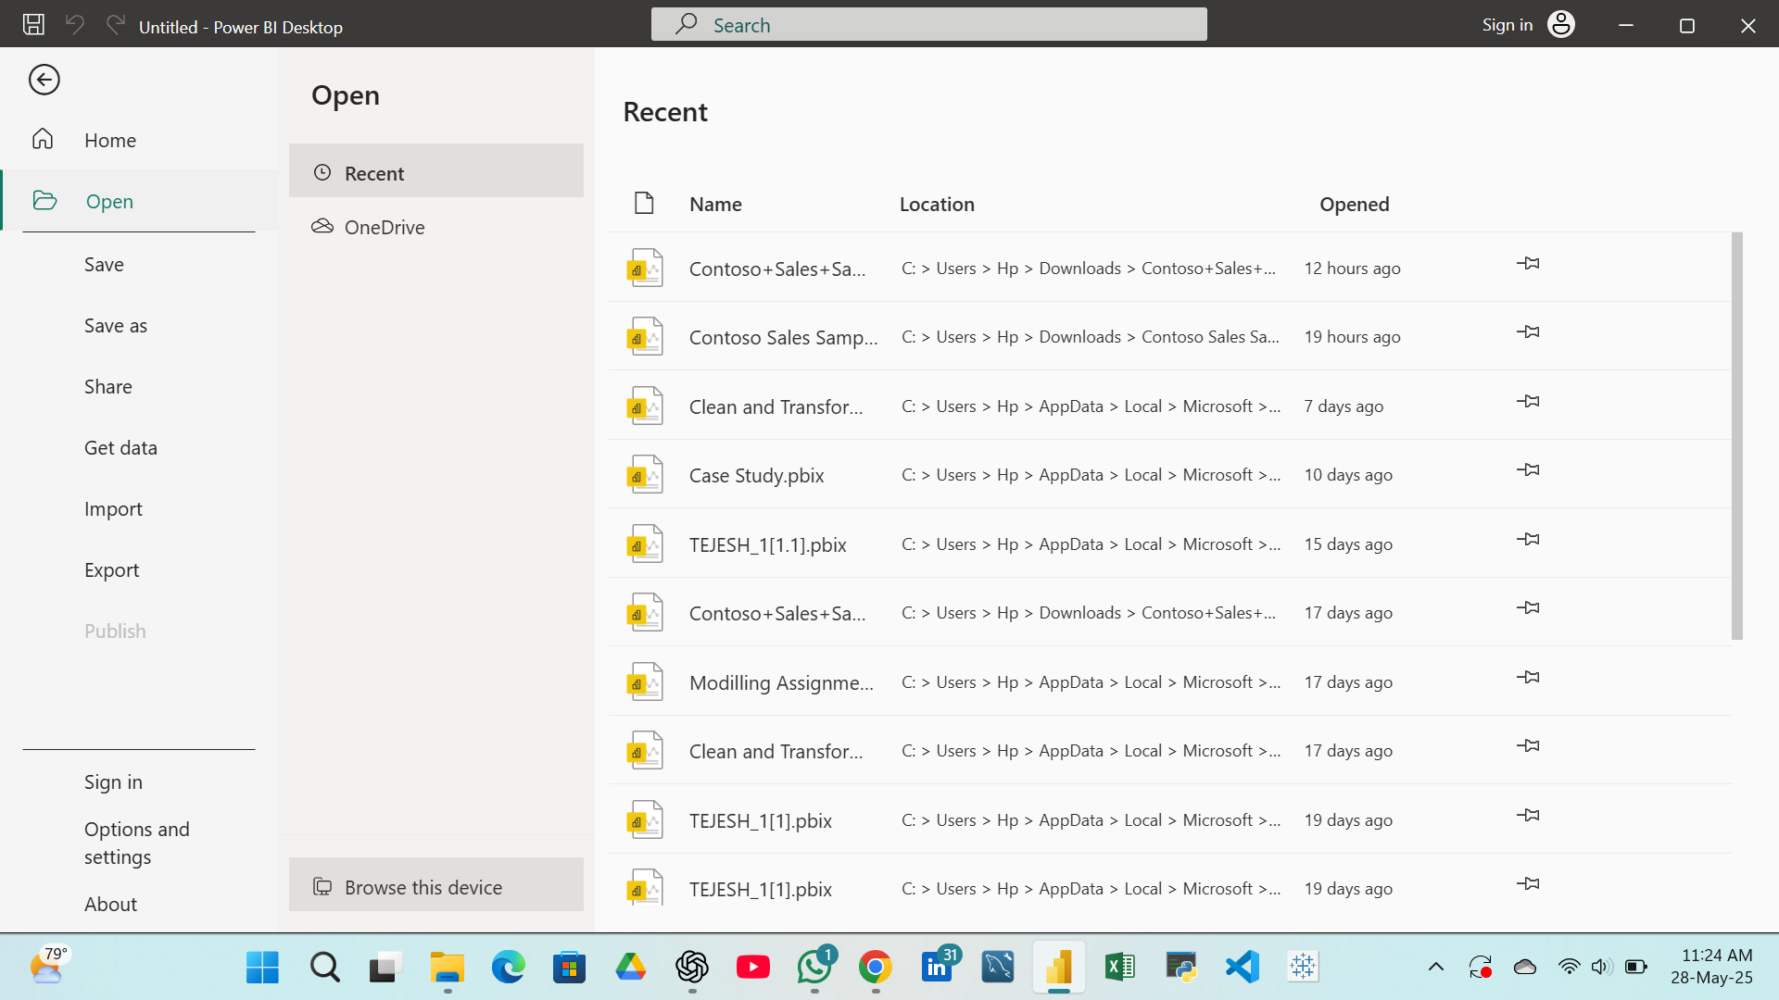

Step 2: Sign in to Power BI
- In Power BI Desktop, click Sign in (top-right).
- Use your Power BI (work or school) account.
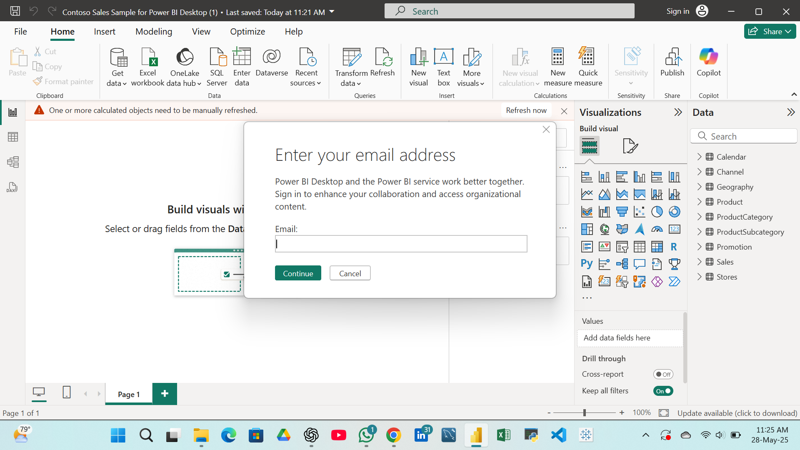

Step 3: Publish to Power BI Service
- Click on the Home tab → click Publish.
- Select “My Workspace” or any other Workspace you have access to.
- Wait for the publishing to complete.
- You’ll see a confirmation message with a “Link to open in Power BI”.
